A campaign to preserve a forest on the Black Isle
BBC Alba 22 August 2024

Allanglach Wood

A member of parliament opposes plans to cut down a Black Isle forest, and he wants the community to look into buying it to save it.

Some in the area are angry that Forestry and Land Scotland (FLS) is going to demolish Allanglach Forest. Allanglach Wood is between North Kessoch and Munlochy - right next to Munlochy Animal Aid Centre.

FLS announced some time ago that they plan to cut down a large part of the forest - six hectares - later this year. They say that the trees are so old and have grown so high that many of them are in danger of falling if there is a storm. They say that they consulted with the people of the area - including the charity that runs the Animal Aid Center there. But the center says that no one asked for their opinions. They think it would be a shame to demolish the facility - which many in the community use for walking and recreation.

The area's member of parliament, Jamie Stone, said that the place is very important in terms of nature - such as the presence of red squirrels and rare species of fungi. He would request a community initiative to buy the place...
"I think there is an additional responsibility towards the public to look after this forest," he said.
"It is a forest that is very loved by the community.
"I hope we can have a positive conversation about this.
"I think there are ways to do things that are much better, and that the people of the area would take with them."

A spokesperson for Forestry and Land Scotland said that the forest could be sold to the community.
But they said that, at this stage, there is no community group that could submit an application.

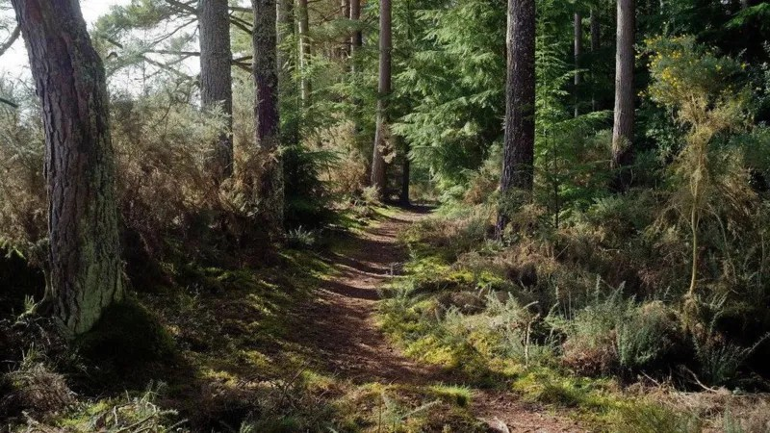
Picture by Julian Paren

